Sudeepto Roy

1546008

MOBILE MASTER

We were given an app as a zip file.

Downloading the zip file and extracting it we found

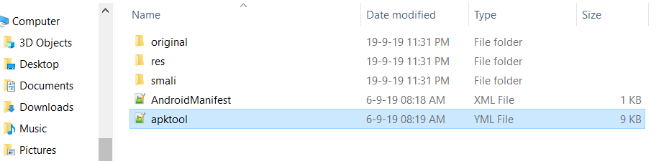

We searched for the flag in several files .

In an app, usually smali directory contains the MainActivity and so we browsed to the MainActivity and opened in notepad.

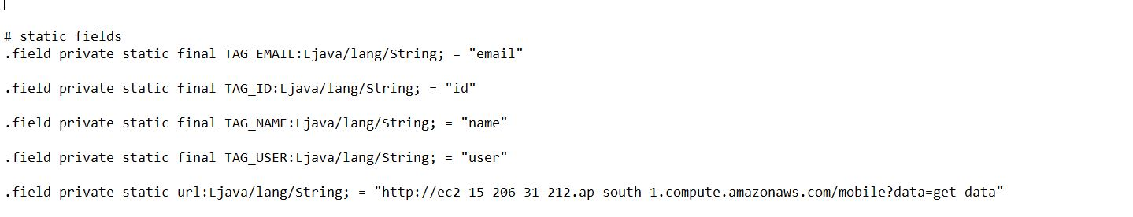

We found an url.

Upon opening the url in a browser, we got our flag .

